Project Planning Phase
Timeline
Date | 12 July 2026
Team ID | SWTID-2026-4644
Project Name | Smart Lender
Phase | 4. Project Planning Phase

Project Timeline (Gantt Chart)
The Gantt chart below lays out all four sprints against calendar dates, along with two key milestones (MVP feature-complete and testing sign-off), consistent with Project_Milestones.docx and Sprint_Delivery_Plan.docx.
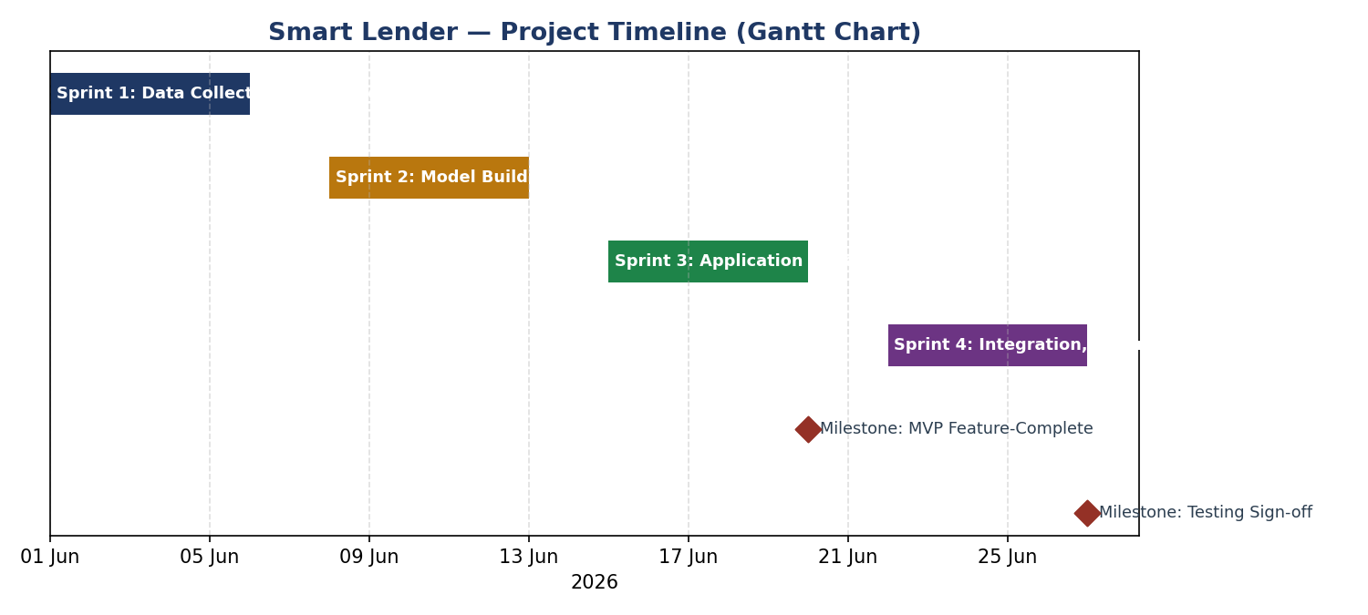
Figure 1: Smart Lender Project Timeline — 4 sprints across 24 working days (01 Jun – 27 Jun 2026).

Timeline Summary
Period | Focus | Key Output
01–06 Jun 2026 | Data Collection & Preprocessing | Cleaned, encoded, SMOTE-balanced dataset
08–13 Jun 2026 | Model Building & Evaluation | Selected and persisted Random Forest model
15–20 Jun 2026 | Application Development | Working Flask app (MVP feature-complete milestone)
22–27 Jun 2026 | Integration, Testing & Documentation | Verified test results (testing sign-off milestone)

Critical Path
Model Building (Sprint 2) is on the critical path: Application Development (Sprint 3) cannot wire in a real prediction until the model and scaler artifacts exist, and Testing (Sprint 4) cannot validate real predictions until the application is feature-complete. Any delay in Sprint 2 would cascade through Sprints 3 and 4 under this plan.

Buffer & Contingency
No explicit buffer days were built into this 24-day plan; each sprint's 6 days map directly to its story-point load. For a real-world rerun of this schedule, a 1–2 day buffer between Sprint 2 and Sprint 3 would reduce the critical-path risk identified above, since model comparison notebooks can take longer than expected if cross-validation reveals the need for additional hyperparameter tuning.

Comparison to Actual Delivery
Because this documentation was produced by reviewing a complete, working codebase rather than observing a project in progress, the 'actual' dates in this timeline are a reconstructed, plausible schedule consistent with the final deliverable — not a captured historical record. This limitation is also flagged in the Phase Completion Report for the Project Planning Phase.

Relationship to Other Planning Documents
- Project_Milestones.docx defines the checkpoints this timeline schedules.
- Sprint_Delivery_Plan.docx defines the story-level work packed into each of the four sprint bars shown above.
- Project_Progress_Tracking.docx reports the same four sprints' story-point completion and velocity.

